1. What is JDBC?

JDBC stands for Java Database Connectivity. JDBC is a Java API to connect and execute the query with the database. It is a part of JavaSE (Java Standard Edition). JDBC API uses JDBC drivers to connect with the database.

The JDBC library includes APIs for each of the tasks mentioned below that are commonly associated with database usage.
- Making a connection to a database.
- Creating SQL or MySQL statements.
- Executing SQL or MySQL queries in the database.
- Viewing & Modifying the resulting records.

1.1 JDBC Architecture
The JDBC API supports both two-tier and three-tier processing models for database access but in general, JDBC Architecture consists of two layers –
- JDBC API − This provides the application-to-JDBC Manager connection.
- JDBC Driver API − This supports the JDBC Manager-to-Driver Connection.

The JDBC API uses a driver manager and database-specific drivers to provide transparent connectivity to heterogeneous databases. The JDBC driver manager ensures that the correct driver is used to access each data source. The driver manager is capable of supporting multiple concurrent drivers connected to multiple heterogeneous databases.

Following is the architectural diagram, which shows the location of the driver manager with respect to the JDBC drivers and the Java application –

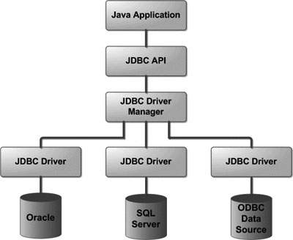

1.2 Common JDBC Components
The JDBC API provides the following interfaces and classes –
- DriverManager − This class manages a list of database drivers. Matches connection requests from the java application with the proper database driver using communication sub protocol. The first driver that recognizes a certain subprotocol under JDBC will be used to establish a database Connection.
- Driver − This interface handles the communications with the database server. You will interact directly with Driver objects very rarely. Instead, you use DriverManager objects, which manages objects of this type. It also abstracts the details associated with working with Driver objects.
- Connection − This interface with all methods for contacting a database. The connection object represents communication context, i.e., all communication with database is through connection object only.
- Statement − You use objects created from this interface to submit the SQL statements to the database. Some derived interfaces accept parameters in addition to executing stored procedures.
- ResultSet − These objects hold data retrieved from a database after you execute an SQL query using Statement objects. It acts as an iterator to allow you to move through its data.
- SQLException − This class handles any errors that occur in a database application.

1.3 The JDBC 4.0 Packages
The java.sql and javax.sql are the primary packages for JDBC 4.0. This is the latest JDBC version at the time of writing this tutorial. It offers the main classes for interacting with your data sources.

The new features in these packages include changes in the following areas –
- Automatic database driver loading.
- Exception handling improvements.
- Enhanced BLOB/CLOB functionality.
- Connection and statement interface enhancements.
- National character set support.
- SQL ROWID access.
- SQL 2003 XML data type support.
- Annotations.

The java.sql package contains classes and interfaces for JDBC API. A list of popular interfaces of JDBC API are given below:
- Driver interface
- Connection interface
- Statement interface
- PreparedStatement interface
- CallableStatement interface
- ResultSet interface
- ResultSetMetaData interface
- DatabaseMetaData interface
- RowSet interface

A list of popular classes of JDBC API are given below:
- DriverManager class
- Blob class
- Clob class
- Types class

1.4 Why Should We Use JDBC
Before JDBC, ODBC API was the database API to connect and execute the query with the database. But, ODBC API uses ODBC driver which is written in C language (i.e. platform dependent and unsecured). That is why Java has defined its own API (JDBC API) that uses JDBC drivers (written in Java language).

We can use JDBC API to handle database using Java program and can perform the following activities:
- Connect to the database
- Execute queries and update statements to the database
- Retrieve the result received from the database.

